21: $

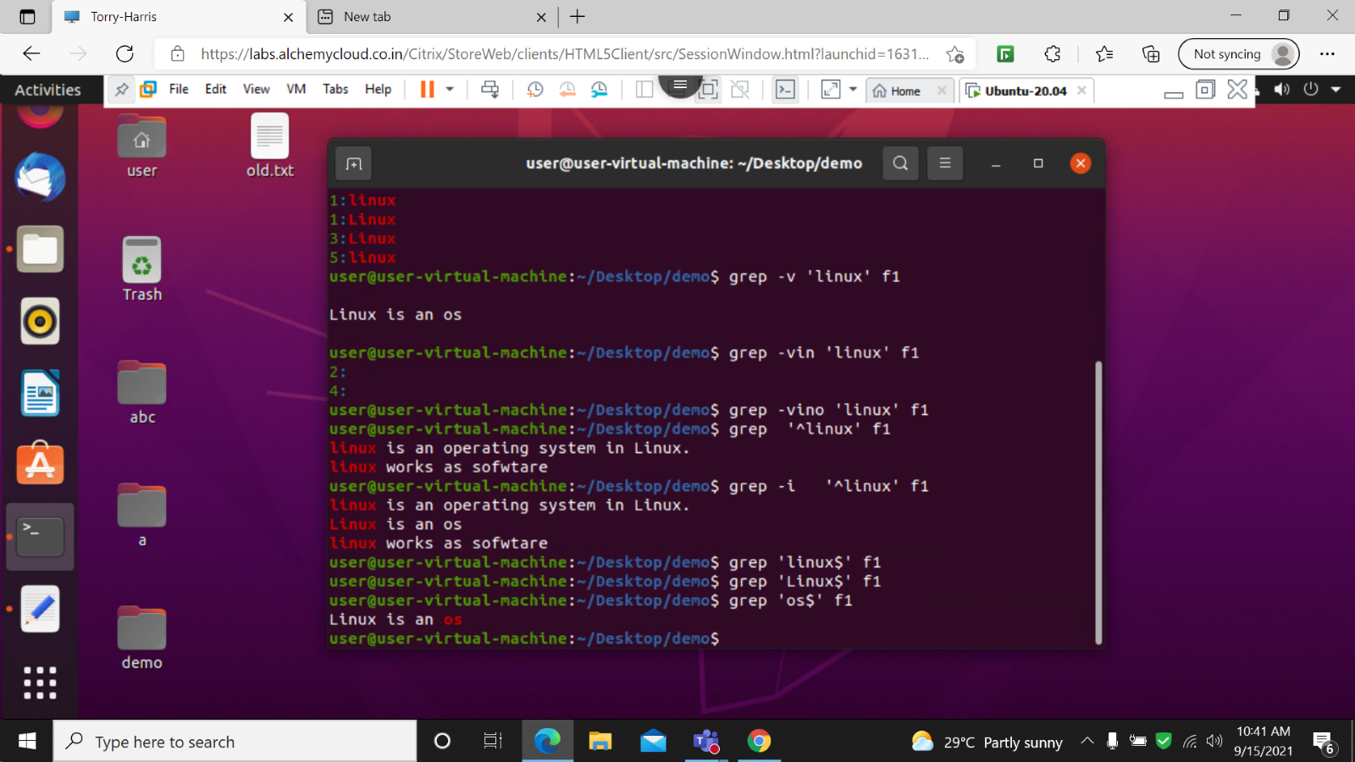

22 : grep ^ os

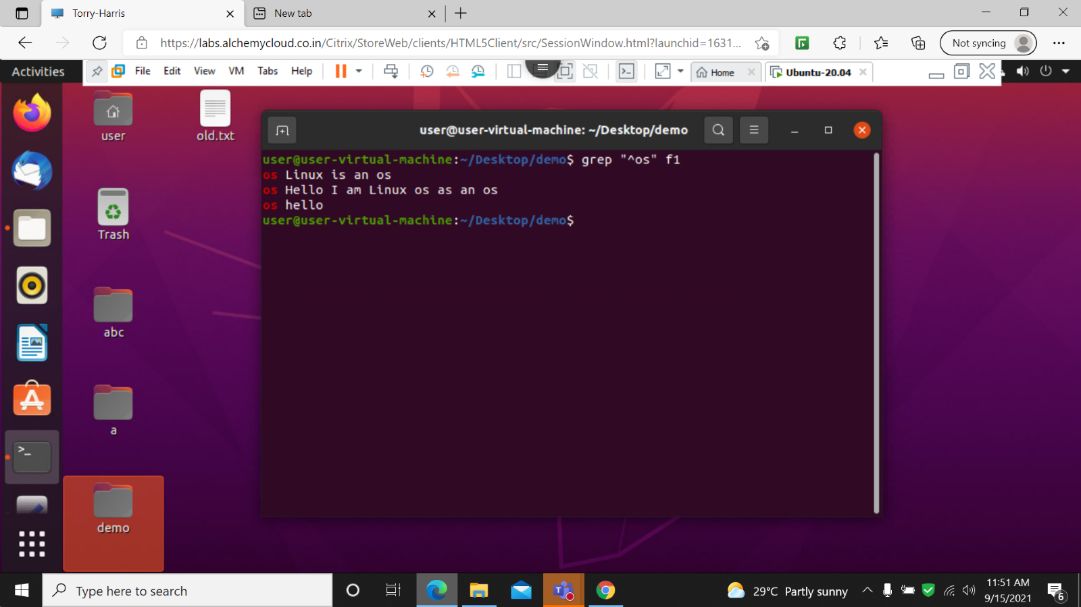

23 grep –n -I ^os

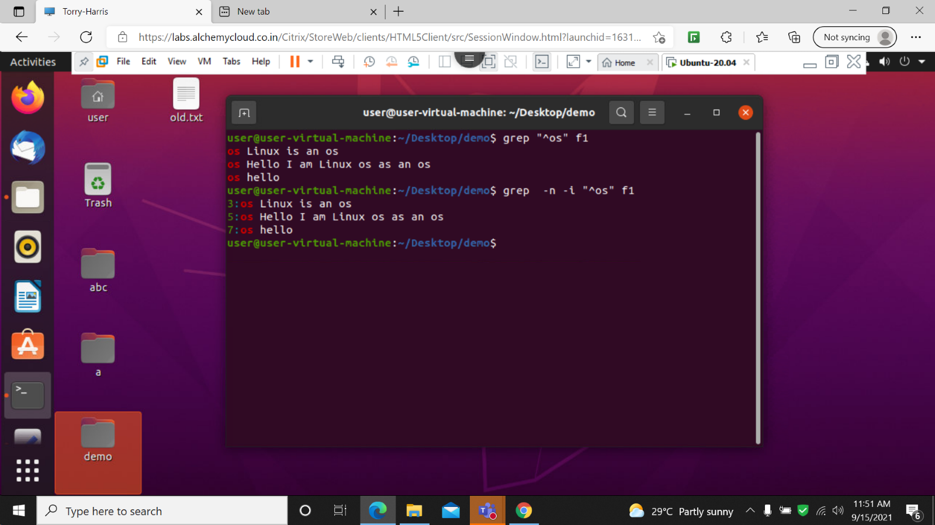

24: grep –n -I os$

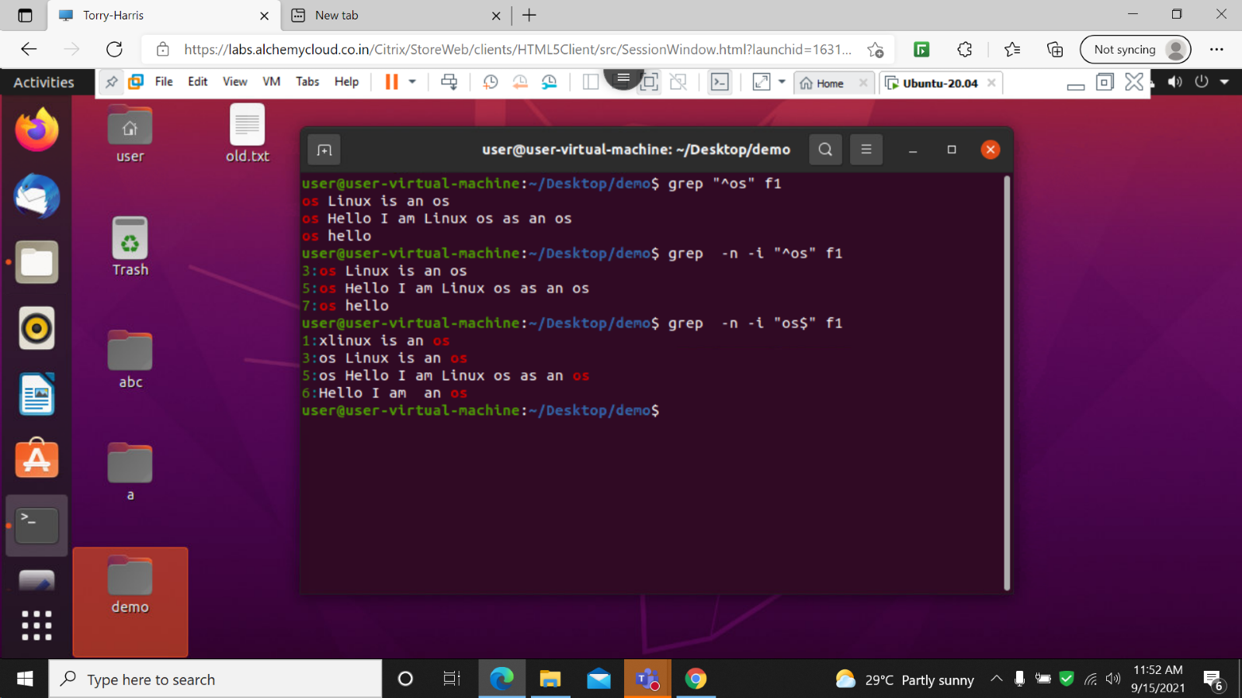

25: grep –n -I “^os.\*os$”

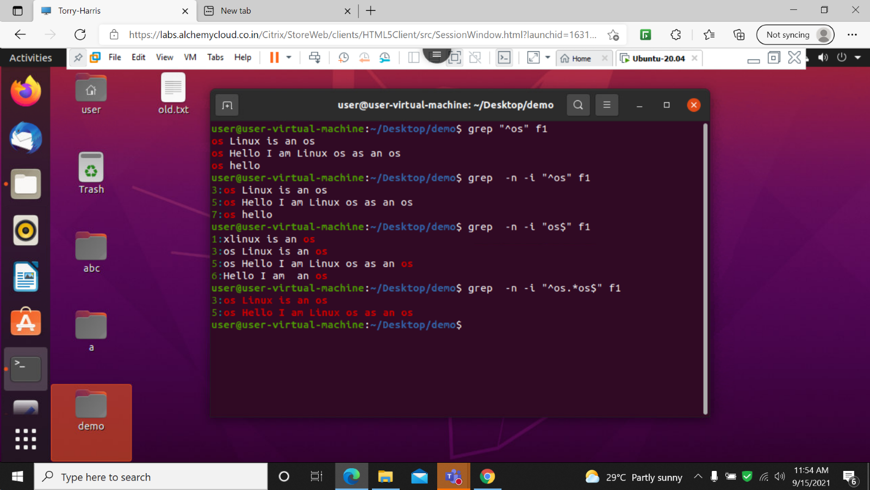

26: grep –n -I –w “^os.\*os$”

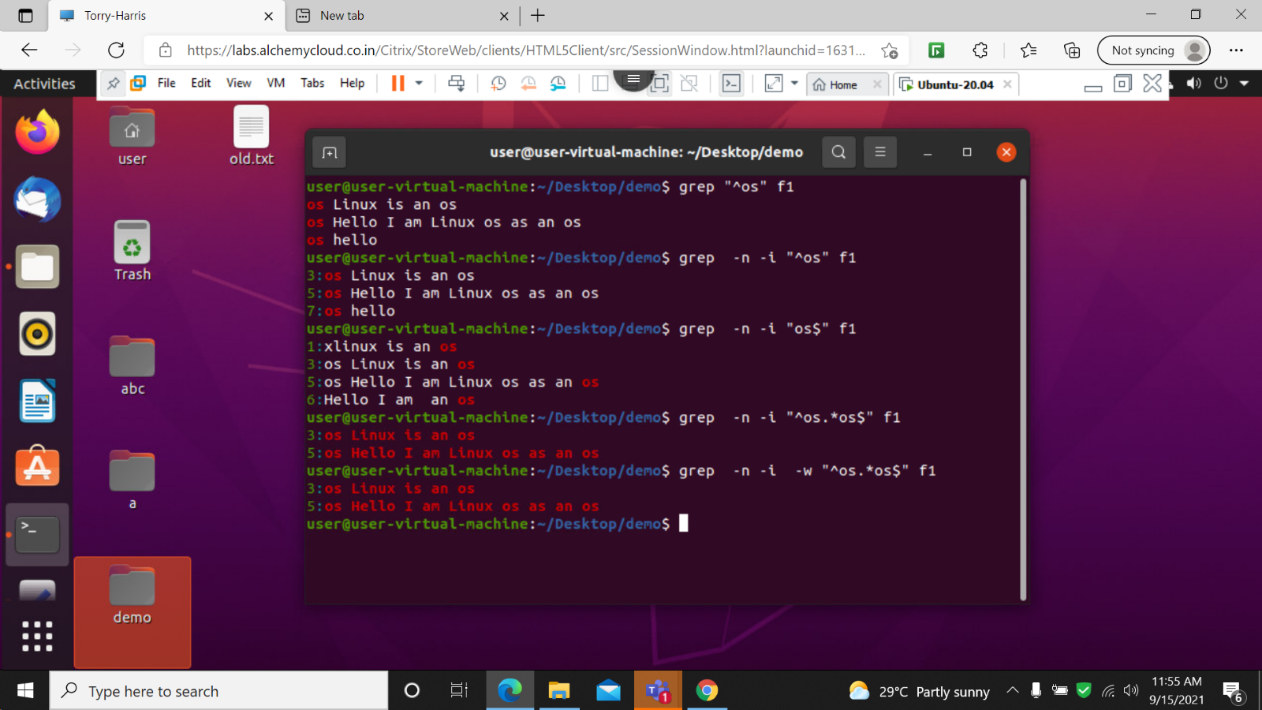

27: grep –n -I –o “^os.\*os$”

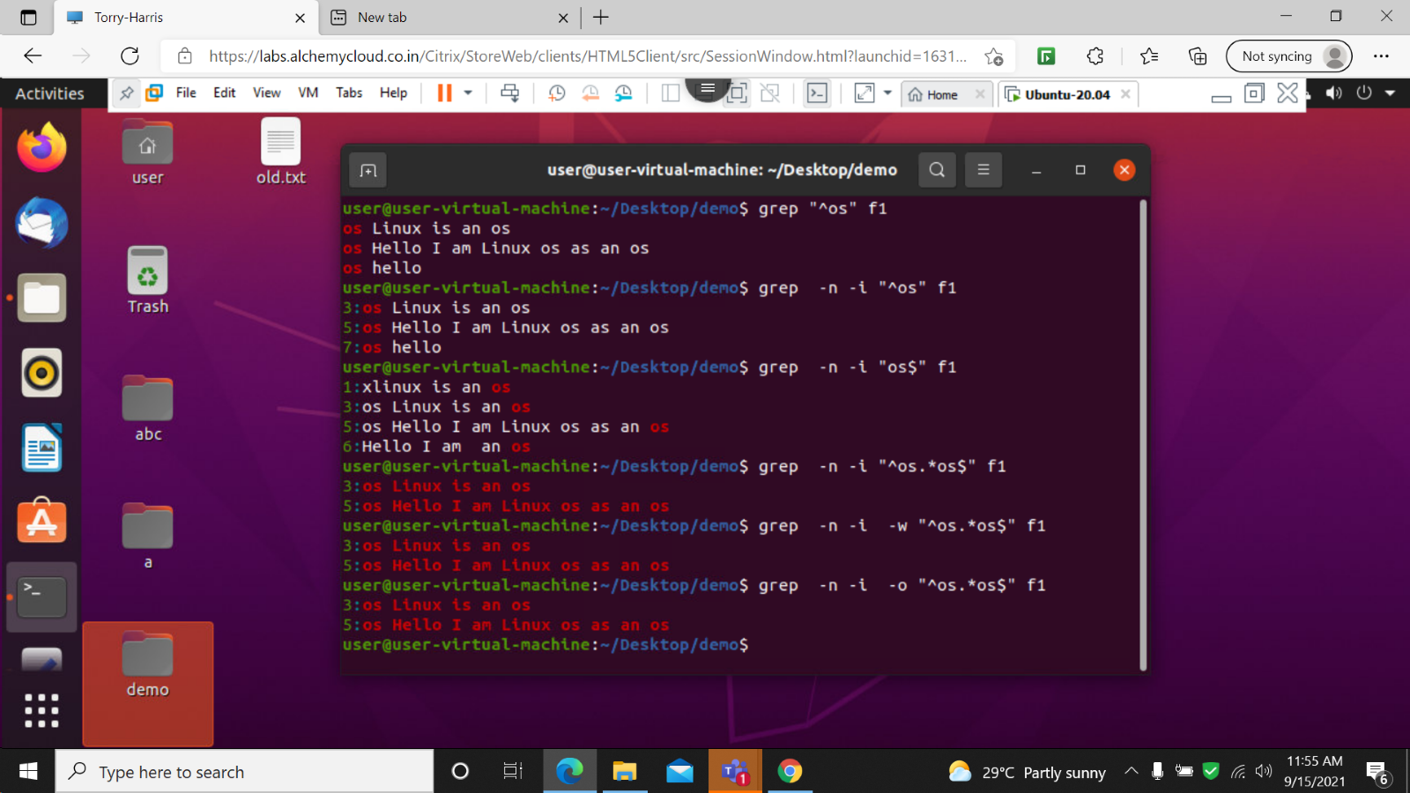

28: grep –ni -E “^h.p$”

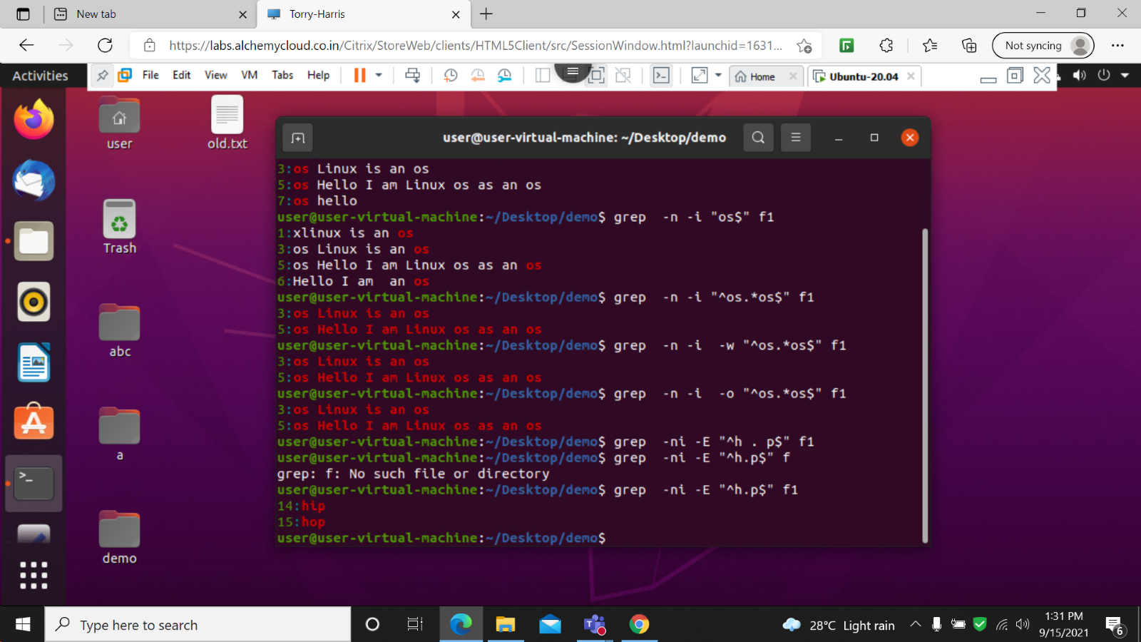

29: grep –ni –E “-h..p$ “

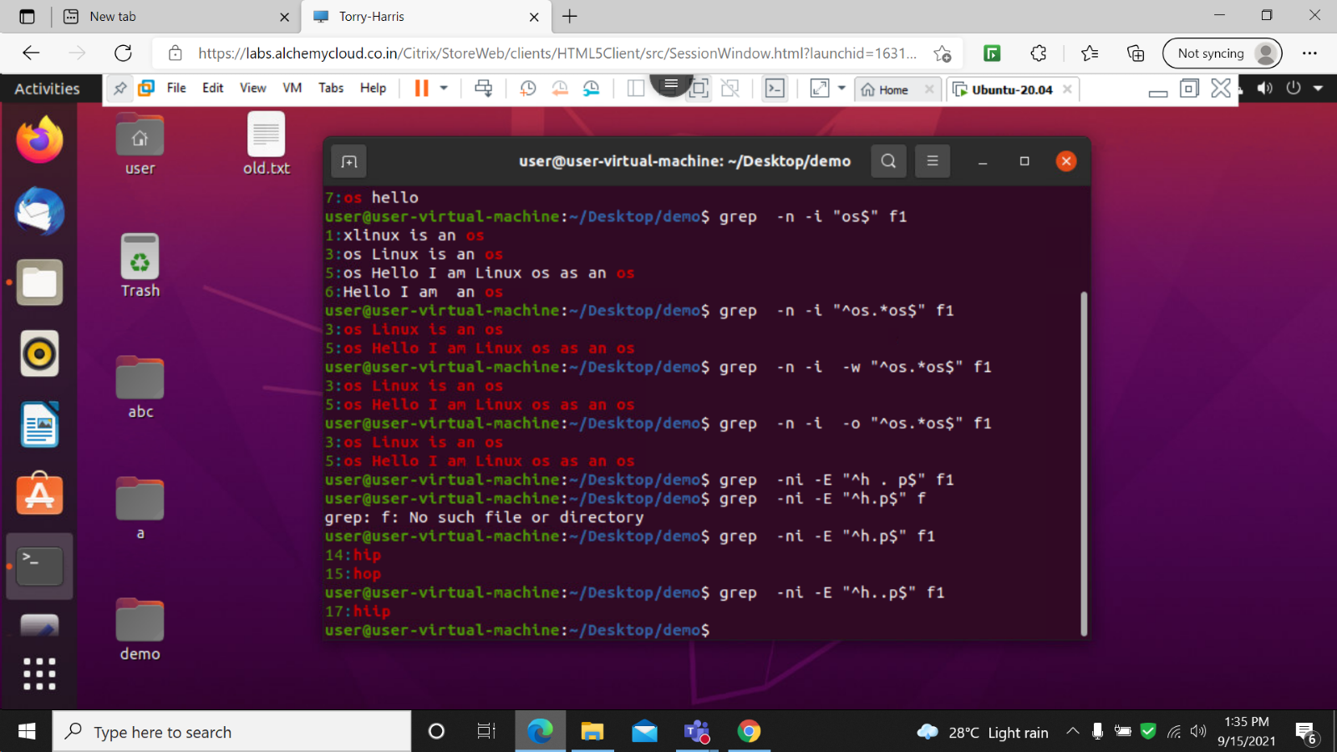

30 : grep –ni –E “-h[ I ]p$”

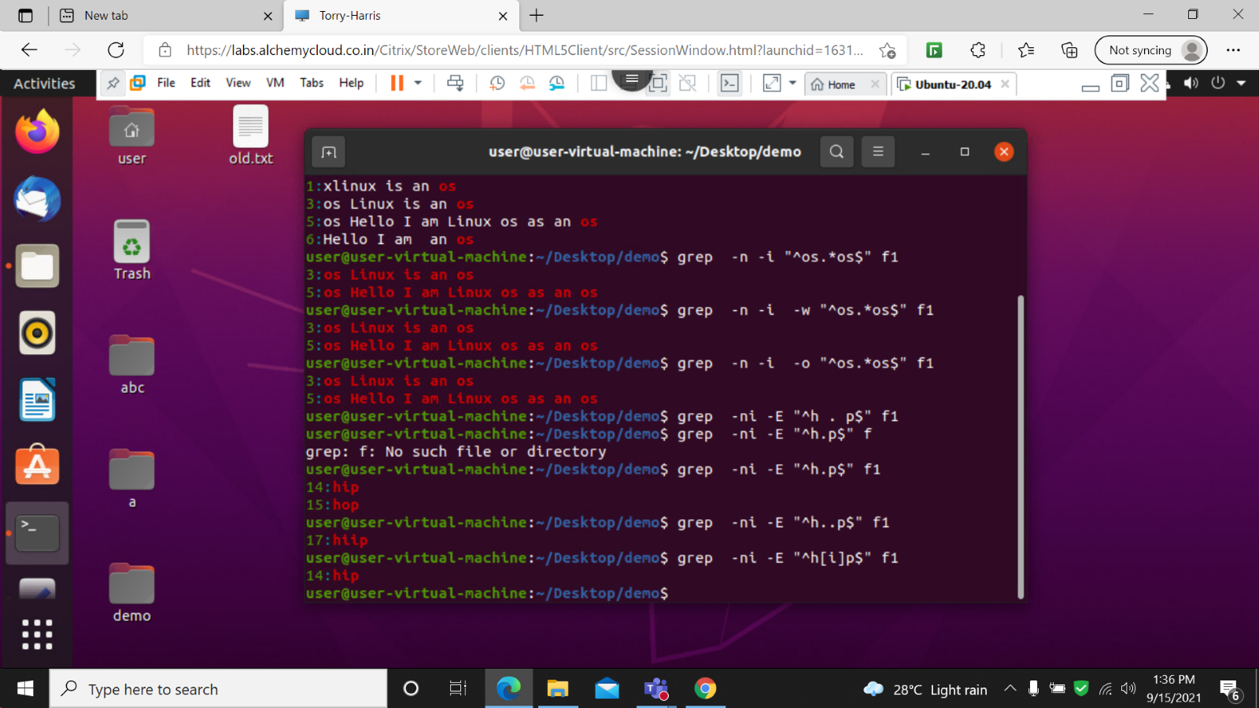

31: grep –ni –E “-h[ Io ]p$”

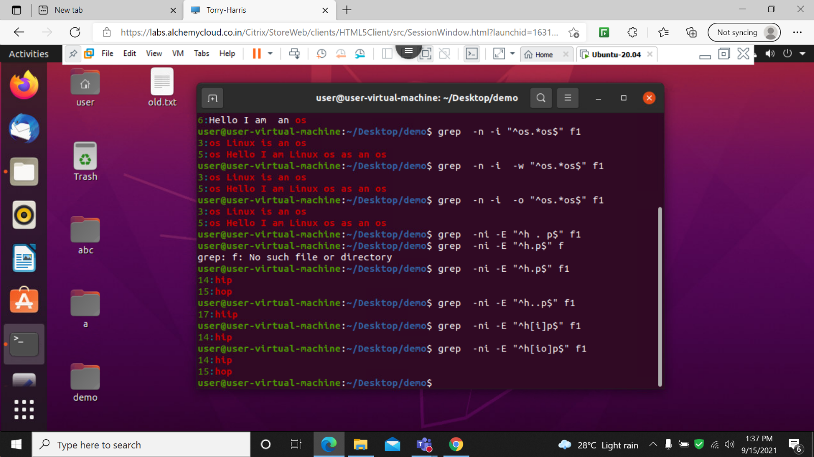

32: grep –ni –E “-h[ Il]p$”

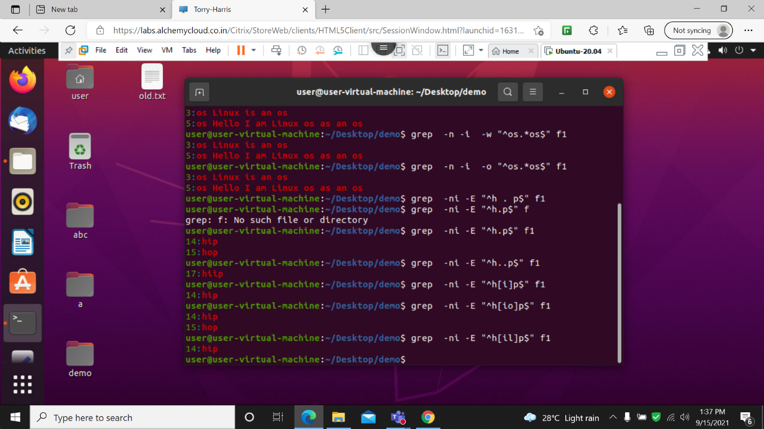

33: grep –ni –E “-h[ lio ]p$”



34: grep –ni –E “-h.\*p$”



35: grep –ni –E “^c..a$”

